Rotational Inertia
Moment of Inertia: The resistance of an object to changes in its rotational motion.

The equation of the moment of inertia varies depending upon the shape of the rotating object. For an object rotating around an axis at a distance r,
Momentum of inertia = (mass) (radius)² or I = mr² The SI unit for moment of inertia is the kilogram meter squared (kg m²) Other moments of inertia are summarized as follows:

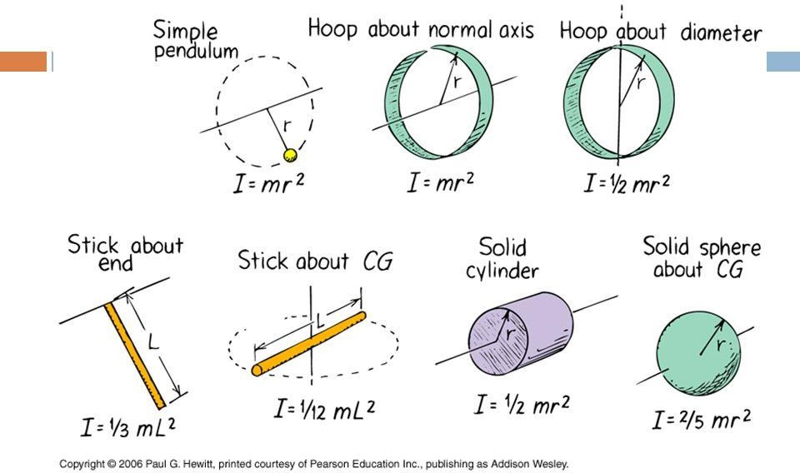

Newton’s first law says that inertia is the tendency of an object to stay at rest or remain in motion in a straight line with a constant speed unless acted upon by an unbalanced force. Similarly, an object that is rotating tends to continue spinning at a constant rate unless an unbalanced force acts to alter that rotation. This is called the rotational inertia.
Think of moment in inertia as being the rotational equivalent of the term “mass.” Just as inertia is greater for a greater mass, rotational inertia is greater for a greater moment of inertia.
- On the Wheel of Fortune game show, a contestant spins the 15.0 km wheel that has a radius of 1.40 m. What is the moment of inertia of this disk-shaped wheel?

- Trish is twirling her 0.60 m majorette’s baton that has a mass of 0.40 kg. What is the moment of inertia of the baton as it spins about its center of gravity?

- At Wellesley College in Massachusetts there is a favorite tradition called hoop rolling. In their caps and gowns, seniors roll wooden hoops in a race in which the winner is said to be the first in the class to marry. Helen rolls her
0.2 kg hoop across the finish line. The moment of inertia of the hoop is 0.032 kg m². What is the radius of the hoop?
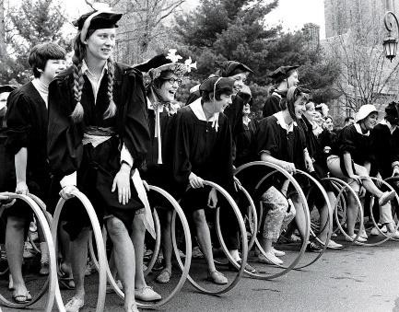

- The earth has a mass of 5.98 X 10²⁴kg and a radius of 6.38 X 10⁶ m. What is the moment of inertia of the earth as it turns on its axis?

- Olga, the 50.0 kg gymnast, swings her 1.6 m long body around a bar by her outstretched arms.
- What is Olga’s moment of inertia?
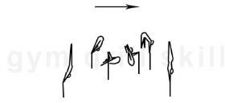

- If Olga were to pull in her legs, thereby cutting her body length in half, how would this numerically change her moment of inertia? (Assume her mass is evenly distributed all along her body.)

- A sphere, disc and a ring have a race down a short incline plane. They equal in mass and diameter. They start at the same time at the same location at the top of the incline plane. Which reaches the bottom first, second, and last? Why?
